KNOWLEDGE REPOSITORY

A knowledge repository is an online database that systematically captures, organizes, and categorizes knowledge-based information. Knowledge repositories are most often private databases that manage enterprise and proprietary information.

* Knowledge from all projects must be documented and collected.
* This knowledge should be organized into a repository that will support decision making for future projects.
* Organization should provide resources and funds for this activity.

There are several key features of effective digital knowledge repositories:

* + **Centralization.**A wide variety of digital courseware, and content curated from multiple sources, can be housed in a central location where it can be tagged, shared and commented upon globally within one consistent interface.
  + **Content management.** The breadth of learning content can include audio visual files, simulations, data, learning modules, articles, blogs, YouTube videos, best practices guidance, monitoring capabilities and contact information. Content is searchable by key words, learning outcomes, and other vehicles.
  + **Cost savings.** Repositories can potentially reduce the cost of training and education by making affordable course materials accessible, reducing the need for classroom training and stimulating productive informal learning.
  + **Access control.** By restricting individual content pieces via password authentication and other security functionality, curators can accomplish various goals. Access controls often involve safeguarding proprietary information and protecting intellectual property. Some, but not all, repositories employ digital rights management (DRM) to protect and monetize intellectual property in the market.
  + **Record management.** Repositories can integrate with learning management systems to blend seamlessly into learning and talent management programs.

In BCI Framework, integrating data related to different brain signals in knowledge repository.

Taxonomy of BCI signal paradigms according to the acquisition methods. ECOG: Electrocorticography, EEG: Electroencephalography, fNIRS: functional near-infrared spectroscopy, fMRI: functional magnetic resonance imaging, EOG: Electrooculography, MEG: Magnetoencephalography.

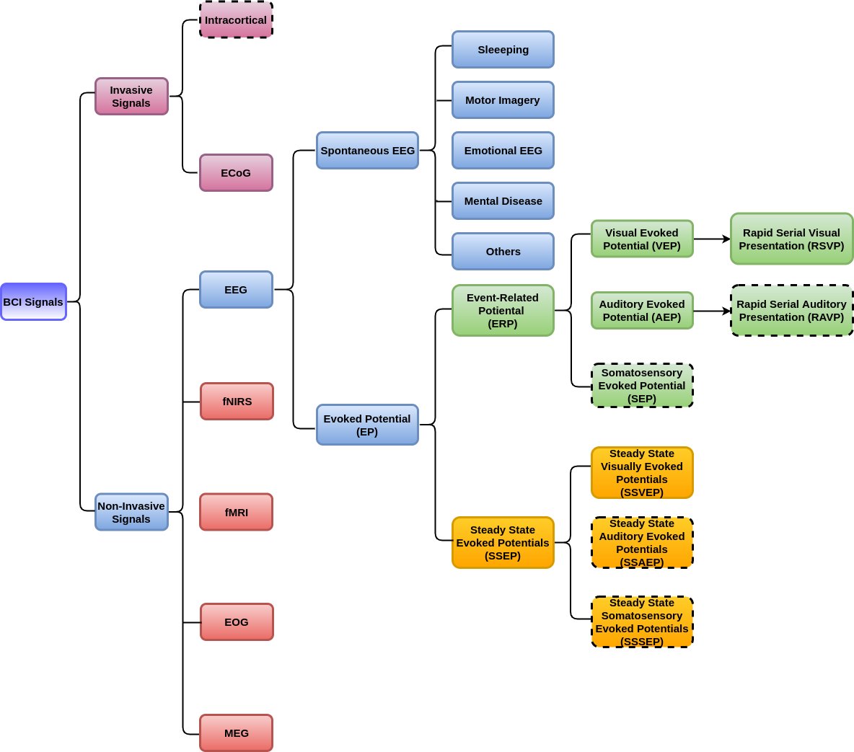

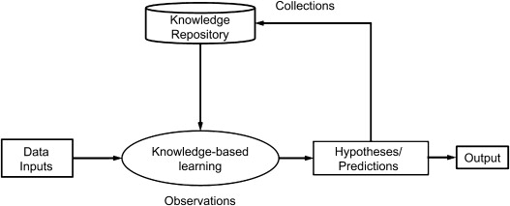

Figure: Basic Flowchart of Knowledge Repository

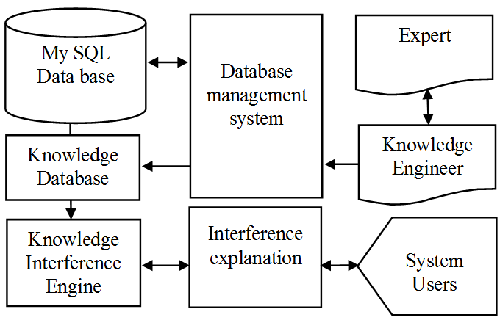

Figure: DBMS Structure

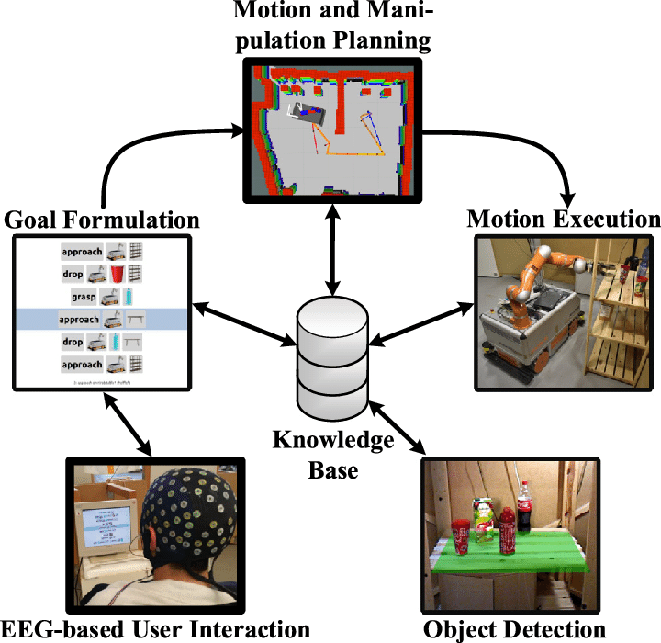

FIGURE: Application of Knowledge Base in BCI